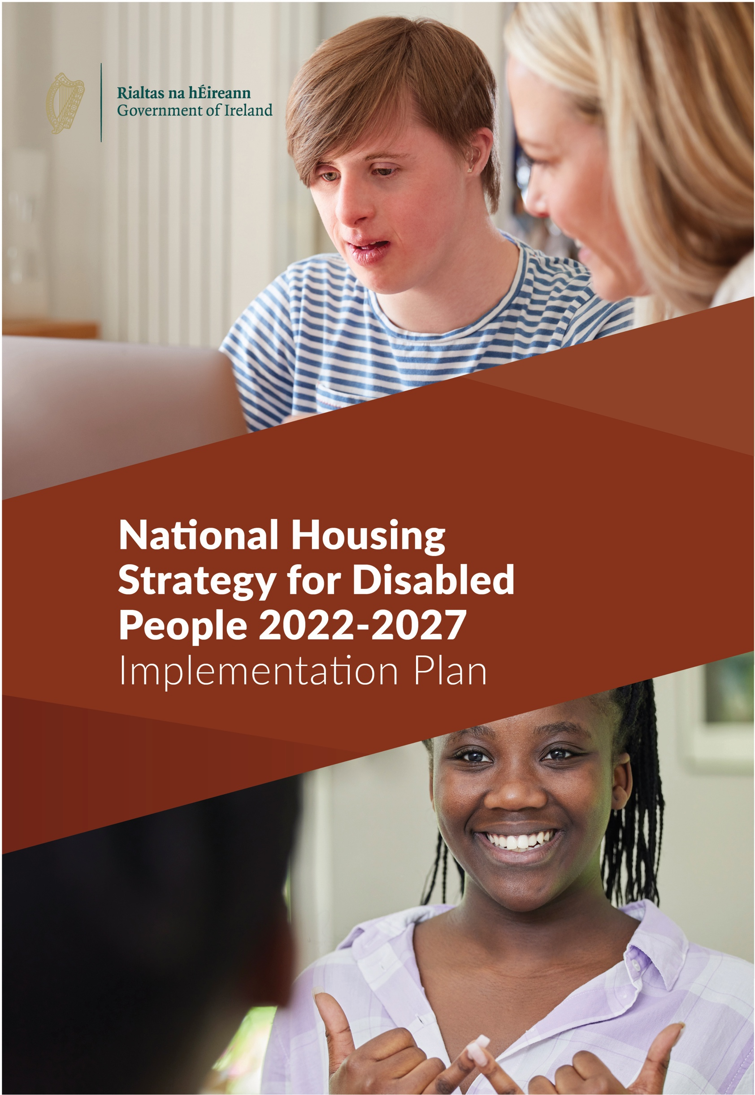

National Housing Strategy for Disabled People 2022-2027 | Implementation Plan

Contents

1. Introduction 2
2. The Vision 5
3. National Housing Policy 7
4. Mapping of Housing and Disability Policies 10
5. Themes 13
6. Implementation Structures 16
7. Update on Implementation of the Strategy and Other Progress 19
8. Funding Commitments 26
9. Outcomes and Actions 28
Theme 1 – Accessible Housing and Communities 29
Theme 2 – Interagency Collaboration and the Provision of Supports 38
Theme 3 – Affordability of Housing 47
Theme 4 – Communication and Access to Information 50
Theme 5 – Knowledge, Capacity, and Expertise 56
Theme 6 – Strategy Alignment 60

1

National Housing Strategy for Disabled People 2022-2027 | Implementation Plan

The National Housing Strategy for Disabled People 2022 – 20271 was published on the 18th of January 2022 by Minister Darragh O’Brien, Minister Peter Burke and Minister Anne Rabbitte. The Strategy is a five-year strategy which sets out the ambitions with regards to housing with related supports for disabled people
during this period. This Strategy will build on the progress made under the previous strategy, The National Housing Strategy for People with a Disability (NHSPWD) 2011 – 2016 (extended to 2021). The Strategy promotes a whole of community approach to housing for disabled people when planning the provision of housing, including infrastructure, transport, education, and employment.
The development of the Strategy, and the suite of documents that accompany it, are informed and underpinned by the United Nations Convention on the Rights of Persons with Disabilities. There are specific articles of the convention that are called out as being significant when developing a housing strategy for disabled people.
- Article 4.1(f) - To undertake or promote research and development of universally designed goods, services, equipment and facilities, as defined in Article 2 of the present Convention, which should require the minimum possible adaptation and the least cost to meet the specific needs of a person with disabilities, to promote their availability and use, and to promote universal design in the development of standards and guidelines.
- Article 4.3 - In the development and implementation of legislation and policies to implement the present Convention, and in other decision-making processes concerning issues relating to
persons with disabilities, States Parties shall closely consult with and actively involve persons with disabilities, including children with disabilities, through their representative organisations.
- Article 9 - To enable persons with disabilities to live independently and participate fully in all aspects of life, States Parties shall take appropriate measures to ensure to persons with
disabilities access, on an equal basis with others, to the physical environment, to transportation, to information and communications, including information and communications technologies and systems, and to other facilities and services open or provided to the public, both in urban and in rural areas.
- Article 19 - Living independently and being included in the community, ensures disabled people have equal rights in accessing housing and equal rights to accessing supports necessary to allow them to live independently within the community.
- General Comment 5 - relates primarily to the obligation to ensure every person’s enjoyment of the right to live independently and be included in the community, and for individuals to have choice and control over where they live, supporting the person’s will and preference.
The Strategy is set out under six themes and each theme has a set of outcomes and initial actions. The National Housing Strategy for Disabled People 2022 – 2027 required that an Implementation Plan be prepared. The Strategy contains a number of initial actions, some of which have commenced and are referenced as underway in this document.
This Implementation Plan builds on the Outcomes and Actions of the Strategy. The Plan documents the actions that will be required to deliver on the outcomes and assigns those actions to identified stakeholders. The Plan also sets out indicative timeframes as well as Key Performance Indicators for each of the actions.
1. gov.ie - National Housing Strategy for Disabled People 2022 – 2027 (www.gov.ie)

3

National Housing Strategy for Disabled People 2022-2027 | Implementation Plan

The Plan will remain fluid with periodic reviews and annual reporting. The Plan will remain agile to respond to changes in circumstance over the lifetime of the Strategy.
The Housing Agency (HA) prepared an initial draft informed by a further round of consultation following publication of the Strategy. This draft was shared with the Department of Housing, Local Government and Heritage (DHLGH).
Extensive bilateral engagements were then undertaken between the DHLGH and the HA to further develop the draft for wider consultation. Subsequently, the DHLGH, assisted by the HA engaged in trilateral consultation with the Department of Health (DoH) and the Department of Children, Equality, Disability, Integration and Youth (DCEDIY) to finalise the Implementation Plan and to ensure its up to date robustness. Consultation also took place with the Local Government Management Agency (LGMA) and the Health Service Executive (HSE).

Mid-term Review
There will be a formal review of the Implementation Plan commencing mid-2024 for completion by Q4 2024. This review will ensure that the outcomes and actions from this plan are still relevant.
The review will also set out the actions for the remaining term of the Strategy and develop new outcomes, if required. The Housing Agency will lead on this review and will present a draft to the tri- department group by the end of Q3 2024.

4

National Housing Strategy for Disabled People 2022-2027 | Implementation Plan

The vision set out in the National Housing Strategy for Disabled People 2022 – 2027 is:

To facilitate disabled people to live independently with the appropriate choices and control over where, how and with whom they live, promoting their inclusion in the community.

To further enable equal access for disabled people to housing with integrated support services.

The vision is supported by the overarching principle of living independently and being included in the community. Each Theme takes account of the outcomes that will need to be in place to deliver on this vision.
The vision will need to be supported by clear commitments from all stakeholders and this Implementation Plan aims to demonstrate these commitments.

6

National Housing Strategy for Disabled People 2022-2027 | Implementation Plan

There are several national policies that informed the Strategy and have contributed to the development of the detail of this Implementation Plan.
The following are short synopses of each of these policies (more detail is contained in the Strategy).

Housing for All2
Housing for All (2021) is the Government’s housing plan to 2030. The overall aim of the housing plan for Ireland is that everyone in the State should have access to a home to purchase or rent at an affordable price, built to a high standard and in the right place, offering a high quality of life. The plan’s vision is to have a steady supply of housing in the correct locations with economic, social and environmental sustainability built into the system. It is estimated that there is a requirement for approximately 33,000 new homes each year to meet the need.
Housing for All provides four pathways to achieving its overarching objectives:
- Supporting Homeownership and Increasing Affordability.
- Eradicating Homelessness, Increasing Social Housing Delivery and Supporting Social Inclusion.
- Increasing New Housing Supply.
- Addressing Vacancy and Efficient Use of Existing Stock.

Time to Move on from Congregated Settings3
The report was adopted as policy, and implementation commenced in 2012. The overall aim of the policy was to move from a situation where people live isolated lives away from any community and from families, with many experiencing institutional living conditions where they lack basic privacy and dignity, to a scenario where people live in their own homes and are facilitated to have opportunities to grow their lives and be connected in their communities. A dedicated “Time to Move On” Subgroup was established to implement the initiatives which underpin and enable a new model for residential support in the mainstream community, where disabled people are supported to live ordinary lives in ordinary places.

Disability Capacity Review to 20324
The Department of Health published the Disability Capacity Review to 2032 – A Review of Social Care Demand and Capacity Requirements up to 2032 in 2021. The report examined the need
for additional care and support services to facilitate disabled people living independently in the community (and associated housing requirements) over the 2018 to 2032 period. The report estimated the need for community-based living with supports arising from the changes forecast.
The report also considered the need to provide alternative residential support options for disabled people inappropriately living in nursing homes, but this could not be completed due to the absence of data.

2 gov.ie - Housing for All - a New Housing Plan for Ireland (www.gov.ie)
3 Time to Move on from Congregated Settings (hse.ie)
4 gov.ie - Disability Capacity Review to 2032 - A Review of Social Care Demand and Capacity Requirements to 2032 (www.gov.ie)

8

National Housing Strategy for Disabled People 2022-2027 | Implementation Plan

Sharing the Vision5
Sharing the Vision (2020) is Ireland’s national mental health policy and is the successor to A Vision for Change (2006). It carries forward those elements of the original policy that still have relevance. It incorporates new recommendations as appropriate to enhance national policy, while simultaneously aligning with the ten-year vision for reform and transformation of Ireland’s health and social care services encapsulated in the Sláintecare report.
Sharing the Vision aims to enhance the provision of mental health services and supports across a broad range of services, from mental health promotion, prevention, and early intervention to acute and specialist mental health service delivery, during the period 2020-2030.

Wasted Lives6
The 2021 Ombudsman Report – “Wasted Lives” examined and considered the impact on people aged under 65 years of age living in nursing homes. This report is based on the findings from an investigation carried out by the Ombudsman. The report points out the very significant challenges in supporting people inappropriately living in nursing homes to transition back to the community and prevent this practice happening in the future.

Universal Design
According to the United Nations Convention on the Rights of Persons with Disabilities, “Universal Design” means the design of products, environments, programmes and services to be usable by all people, to the greatest extent possible, without the need for adaptation or specialised design. The Centre for Excellence in Universal Design at the National Disability Authority published a set of Universal Design (UD) Guidelines for Homes in Ireland in 2015.

Public Sector Duty7
All public bodies in Ireland have responsibility, under the Public Sector Equality and Human Rights Duty or Public Sector Duty, to promote equality, prevent discrimination and protect the human rights of their employees, customers, service users, and everyone affected by their policies and plans.

5 gov.ie - Sharing the Vision: A Mental Health Policy for Everyone (www.gov.ie) 6 Wasted Lives | The Office Of The Ombudsman
7 gov.ie - Public Sector Equality and Human Rights Duty (www.gov.ie)

9
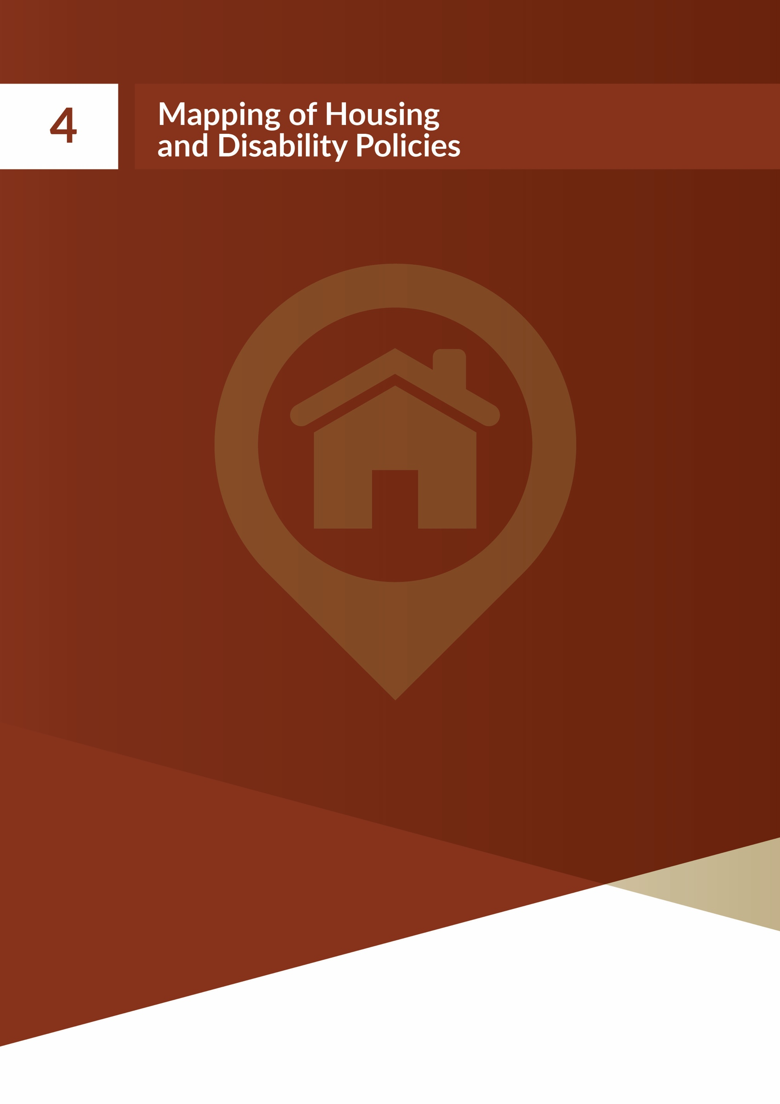

National Housing Strategy for Disabled People 2022-2027 | Implementation Plan

The following is the list of policies and strategies that have been identified as relevant and important when considering housing for disabled people. More detail on the housing and disability aspects of the policies and strategies will be contained in due course in a paper available on the Housing Agency’s website as part of this Implementation Plan.

List of Policies:

Overarching laws, policies and strategies
United Nations Convention on the Rights of Persons with Disabilities (UNCRPD)
Public Sector Equality and Human Rights Duty (the Public Sector Duty)
Assisted Decision-Making (Capacity) Act 2015
Disability Act 2005
National Disability Inclusion Strategy (NDIS)
Government Statement of Strategy 2021-2023

Housing policies and strategies
Housing for All – a New Housing Plan for Ireland
National Housing Strategy for Disabled People 2022-2027
Housing Delivery Action Plans (each LA)
Local Strategic Plans (each LA)
The National Guidelines for the Assessment and Allocations Process for Social Housing Provision for People with a Disability
Approved Housing Bodies Standards, Approved Housing Bodies Regulatory Authority

Health policies and strategies
Disability Capacity Review to 2032 - A Review of Social Care Demand and Capacity Requirements to 2032
HSE National Service Plan
The Capital Plan by the HSE
Sharing the Vision: A Mental Health Policy for Everyone
Wasted Lives: Time for a Better Future
Value for Money and Policy Review of Disability Services
HSE’s Safeguarding Vulnerable Adults Policy
Sláintecare Implementation Strategy and Action Plan 2021-2023
Time to Move on from Congregated Settings
Connecting for Life 2015-2024

11

National Housing Strategy for Disabled People 2022-2027 | Implementation Plan

Built environment policies and strategies
Part M of the Building Regulations
County Development Plans (each LA)
Design Manual for Quality Housing
National Standards for Residential Services for Children and Adults with Disabilities
National Transport Authority Statement of Strategy 2018 – 2022
Building for Everyone: A Universal Design Approach
Accessibility and Usability of the Built Environment - Functional Requirements
Shared Space, Shared Surfaces and Home Zones from a Universal Design Approach for the Urban Environment in Ireland
Code of Practice on Accessible Heritage Sites

Other relevant policies and strategies
Progressing Disability Services for Children and Young People
National Policy on Access to Services for Children & Young People with Disability and Developmental Delay
Project Ireland
National Planning Framework
Healthy Ireland Framework
EU (Accessibility of Websites and Mobile Applications of Public Sector Bodies) Regulations
Sustainable, Inclusive, and Empowered Communities
Local Economic and Community Plans Guidelines
Local Government Reform Act
Climate Action Plan
Our Rural Future – Rural Development Policy 2021-2025
Project Ireland 2040 comprising of the National Planning Framework and the National Development Plan 2021-2030
EU Strategy for the Rights of Persons with Disabilities
The Roadmap for Social Inclusion Strategy 2020-2025
Cost of Disability in Ireland Report

12

National Housing Strategy for Disabled People 2022-2027 | Implementation Plan

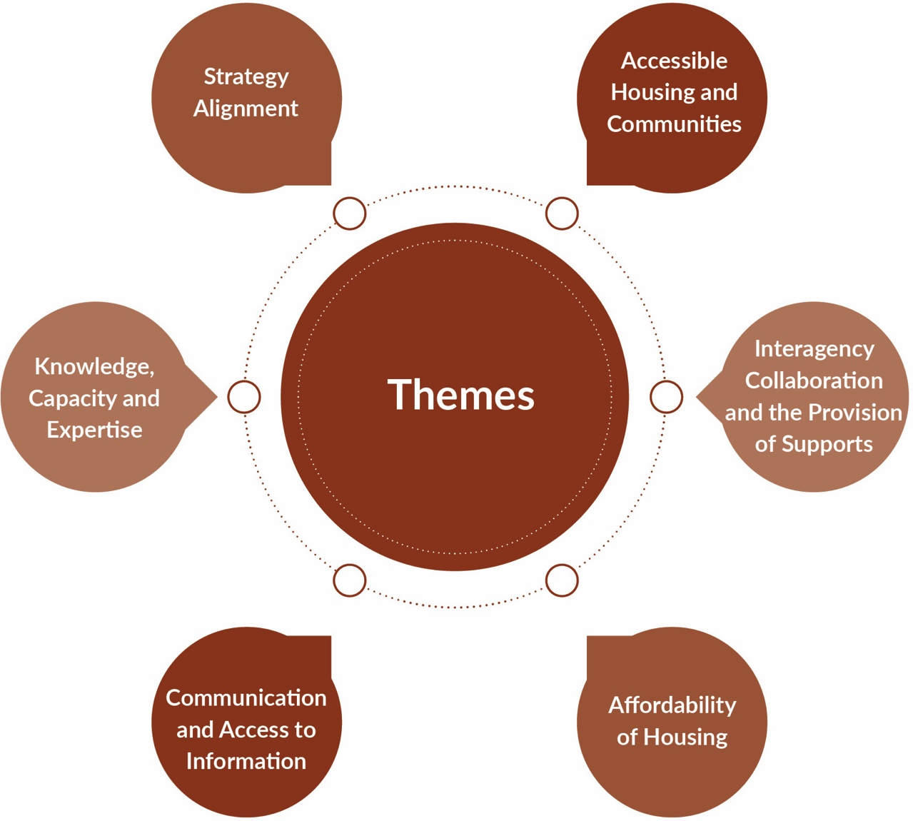

Theme 1 – Accessible Housing and Communities
This theme focuses on the provision of accessible housing for disabled people, the promotion of accessible communities and universally designed homes. It is informed by the United Nations Convention on the Rights of Persons with Disabilities (UNCRPD) and, in particular, “Article 19 -
Living independently and being included in the community” and “Article 9 – Accessibility” which aims “to enable disabled people to live independently… and ensure disabled people have access, on an equal basis with others, to the physical environment.”

Theme 2 – Interagency Collaboration and the Provision of Supports
This theme includes outcomes relating to the improvement of effective collaboration between local authorities and the HSE, better inter-departmental cooperation, aligning housing and support services and the sharing of relevant information between agencies.
This theme seeks to build on the work that has already been done during the NHSPWD 2011 to 2016 (extended to 2021) by strengthening the existing structures and by improving collaboration between all relevant agencies.

14

National Housing Strategy for Disabled People 2022-2027 | Implementation Plan

Theme 3 – Affordability of Housing
This theme focuses on enabling access to affordable housing for disabled people. In keeping with Housing for All and, in particular, “Pathway 1 - Supporting Home Ownership and Increasing
Affordability”, it is important that disabled people are included in the provision of affordable housing. This theme examines these issues and addresses the challenges disabled people may experience living in the private sector, in terms of home ownership and private renting.

Theme 4 – Communication and Access to Information
This theme focuses on communication and access to information. The Strategy will continue to build on the accessible information achievements of the previous Strategy such as the Housing Options documents, the Easy-to-Read Guide to Completing the Social Housing Application Form and the Moving in Checklist. The Strategy is cognisant of the fact that communication is a two-way process.
The Strategy will aim to ensure that disabled people are not disadvantaged in communicating their needs and in the communication they receive. This includes providing information in a range of accessible formats and using the various channels of communications disabled people prefer, while ensuring that adequate time is made available to enable people to engage with local authorities and relevant agencies.

Theme 5 - Knowledge, Capacity, and Expertise
This theme puts forward measures to increase awareness and understanding of disability and housing within the relevant organisations. It also places an emphasis on increasing awareness regarding disabled people’s effective participation and inclusion in their communities. It includes outcomes relating to the building of knowledge and expertise within the housing sector on disability and the building of knowledge and expertise within the health and social care sector on housing. It also acknowledges areas where cross-agency training is necessary, for example, the introduction and application of the Assisted Decision-Making (Capacity) Act 2015.
Relevant organisations include local authorities, Approved Housing Bodies, the HSE and disability service providers.

Theme 6 – Strategy Alignment
This theme places a focus on ensuring that all Government strategies and policies from a housing perspective promote the rights of disabled people, in line with the UNCRPD. This will ensure that the new Strategy 2022 – 2027 complements and supports other strategies related to disability.
These include Sharing the Vision, the Time to Move on From Congregated Settings strategy for de- congregation, and in line with the Programme for Government commitment, to make progress on the need for housing with relevant supports identified in the Disability Capacity Review to 2032.
This theme will also place a focus on aligning other strategies and policies, such as Housing for All, the new Housing Delivery Action Plans established under its framework, and the Public Sector Duty.

15

National Housing Strategy for Disabled People 2022-2027 | Implementation Plan

Theme 2 highlights the importance of interagency cooperation and collaboration.
Cooperation and collaboration structures were established under the National Housing Strategy for People with a Disability 2011 to 2016 (extended to 2021). The new Strategy 2022 to 2027 seeks to build on the work that has been done in establishing structures and to bring the work of the groups to the next level.
The following structures are contained in the Strategy:
- National Implementation Steering Group (Established)
- Housing and Disability Steering Groups (Established)
- National Thematical Focus Groups (Being established)
- Regional Interagency Groups (Being established)
- Bi-monthly meetings of the dedicated disability personnel in local authorities (Being established)

National Implementation Steering Group
This group, established in February 2023, is responsible for driving the implementation of the Strategy and the monitoring of progress. This group is chaired by The Housing Agency and meets on a bi-monthly basis. There will be an annual monitoring meeting of the Steering Group which will be chaired by the Assistant Secretary General of the Department of Housing, Local Government and Heritage. The membership of the National Implementation Steering Group will be reviewed annually.
The National Implementation Steering Group will establish the appropriate linkages in respect of housing with the planned forum being formed to create a link between central Government and local authorities on the application of the UNCRPD at local authority level.
It will be open to the National Implementation Steering Group to refer any issues or barriers arising to the three Departments (DHLGH, DoH, and DCEDIY) who will engage as appropriate to focus
on expediting decision-making at a senior level to ensure any barriers are dealt with at national Departmental level.

Housing and Disability Steering Groups (HDSGs)
Housing and Disability Steering Groups (HDSGs) were established in each local authority area under the National Housing Strategy for People with a Disability 2011 to 2016 (extended to 2021).
The new Strategy reaffirms the structure of the Housing and Disability Steering Groups as the most effective forum for the delivery of the outcomes of the Strategy at local level. The Strategy also stated that the membership of the existing HDSGs must be reviewed in Quarter Three of 2023 to ensure that the membership is consistent with that set out in Section 11.2 (pg72) of the Strategy.
Each Group will review and agree their terms of reference based on the requirements of Housing for All and this Strategy. The terms of reference for each Group will be submitted to the National Implementation Steering Group via The Housing Agency no later than the end of Quarter Four of 2023
The Groups will be required to review and consult as appropriate on their Local Strategic Plan by the end of 2023 to ensure that it aligns with the Strategy and Housing for All.

17

National Housing Strategy for Disabled People 2022-2027 | Implementation Plan

National Thematic Advisory Focus Groups
Individual advisory focus groups will be established from 2023 for each theme to advise the National Implementation Steering Group as required on the actions under the relevant themes. The membership of the groups will be drawn from people with lived experience, experts in the relevant areas and other interested parties. The Groups will be convened by The Housing Agency as required, as actions are progressed. The Housing Agency will provide administrative support to the groups.

Regional Interagency Groups
Initially these Groups will be established based on the HSE Community Healthcare Organisation (CHO) areas but will be aligned to any reorganisation of these areas over the lifetime of the Strategy. The role of these Groups will be to bring together the local authority dedicated disability representatives and the HSE dedicated housing representatives for both Disability Services and Mental Health Services to allow for cooperation and collaboration at an operational level. The Groups will be facilitated by The Housing Agency, who will chair and provide administrative support to the Groups and will meet at least each quarter. A national forum of all the Regional Interagency Groups will be held annually.

Bi-monthly Meetings of the Dedicated Disability Personnel in Local Authorities
This Strategy requires a dedicated disability resource within the housing department of each local authority who will be responsible for the coordination of the interagency collaboration. The Housing Agency will facilitate a bi-monthly meeting of the dedicated disability personnel in local authorities to try to ensure consistency of practice across local authorities (including in the quarterly reporting to the local authority’s Strategic Policy Committee and the National Implementation Steering Group). These meetings will also act as a platform for problem solving or escalation of issues and will identify areas of policy or practice where training needs arise.

18

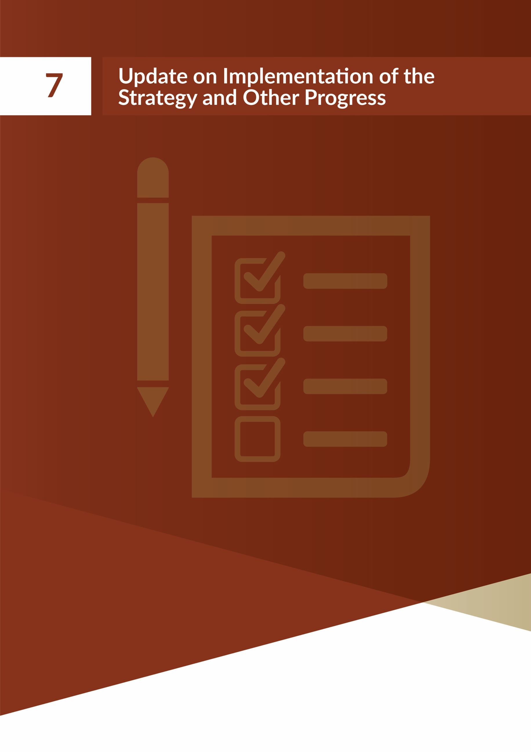

The Implementation Plan contains 27 Outcomes with 107 Actions. A number of these actions contain multiple interim actions, with 25 actions underway and ongoing, and a number complete.
Housing for All is the framework document under which the Strategy and this Implementation Plan are being delivered. It contains six actions relating to housing for disabled people. All of the actions are either complete or underway as outlined.

Action 7.1

Deliver a new National Housing Strategy for People with a Disability (2022 – 2027) following stakeholder and public consultation and with a range of actions which will detail co-ordination and alignment of housing, health and community supports.
Progress:
The Housing Agency coordinated wide stakeholder consultation to develop the Strategy and in preparing the Implementation Plan. The Strategy and this Implementation Plan have been published.

Action 7.28

Local Authority Housing Delivery Action Plans will set out how dedicated social housing provision appropriate to the needs of disabled people will be delivered matching the scale and extent of housing need identified for people with a disability.
Progress:
All local authorities submitted a Housing Delivery Action Plan (HDAP) in December 2021. The plans set out details of each local authority’s delivery of social housing over the period 2022- 2026. They were informed by the targets for social housing delivery contained in Housing for All, and individual targets issued to each local authority for the same period. The Plans also address other specific policy measures such as housing for disabled people. They set out details of local authority delivery in addition to other delivery partners, including Approved Housing Bodies. This is the first such multi-annual delivery planning undertaken by the sector and will be an interactive process throughout the 5 years. The Plans are a key business tool in supporting the development of the housing pipelines required to meet the Housing for All targets and will assist in overall planning for other stakeholders such as water and electricity utility providers.
Local authorities published their Housing Delivery Actions Plans on their websites from Q2 2022

8 Corresponding action within this Implementation Plan is 6.1.1

Action 7.39

Local authorities will consider the housing needs of people with a disability through the Housing Need and Demand Assessment (HNDA) Framework and feed that into their Housing Strategies as part of their Development Plan process.

Progress:
The HNDA comprises a standardised methodology that can quantify the current and projected housing needs of a particular local authority area, including in relation to requirements for different tenures (owner occupier, private rented, social rent and affordability constraint). It is the central evidence-base informing local authority Housing Strategies (under s.94 of the Planning and Development Act 2000), which in turn inform the housing policies of the respective City
or County Development Plan. The HNDA Framework and Tool were published in April 2021. Research by the Economic and Social Research Institute (ESRI) on Regional Demographics and Structural Housing Demand at a County Level, published in December 2020, provides a robust, up-to-date and independently developed housing demand projection to inform policy and investment regarding housing at national and local levels. The research underpins structural housing demand within the HNDA Tool, forming the basis of national housing supply targets to 2030, and informing Housing Strategy and City and County Development Plan processes at local authority level.
Guidelines on Housing Supply Target Methodology for Development Planning, prepared under
s.28 of the Planning and Development Act 2000, were issued by the Department of Housing, Local Government and Heritage in December 2020 further to NPO 36 of the National Planning Framework. The guidelines provide a national methodology for each planning authority to estimate an overall housing supply target for their Development Plan that is consistent with adopted national and regional growth targets in the National Planning Framework and Regional Spatial and Economic Strategies. Government published its Housing for All Action Plan Update on 2 November 2022. It sets out the Government’s approach to reviewing and refreshing the current targets and projections. The HNDA framework and housing targets will be reviewed as part of this work. As a critical element of this work, the ESRI will update its research on structural housing demand once the detailed Census data is available in June 2023. The work will be completed towards the end of 2023, with refreshed targets agreed thereafter.

9 Corresponding action within this Implementation Plan is 6.1.1

Action 7.410

Review the range of housing grants available to assist with meeting specific housing needs, including the Housing Adaptation Grant for People with a Disability, and implement relevant changes.
Progress:
A report on the review of the Housing Adaptation Grants for Older People and People with a Disability has been prepared. Among the areas which the review considered were the income thresholds, and grant limits, and the application and decision making processes, including supplementary documentation required.

Action 7.511

Nominate Disability Friendly Housing Technical Advisors in each local authority.
Progress:
Government policy is to support disabled people to live in their own homes and communities with dignity and independence, for as long as possible. The aim is to ensure that disabled people will have greater choice by developing a range of housing options that are suited to their needs, so they can plan ahead and, insofar as possible, choose the right home for them. All local authorities have nominated a staff member to undertake the role of Disability Friendly Housing Technical Advisors so that this resource is available across the country. A member of staff at
the appropriate technical level of expertise has been nominated to provide specialist advice to the authority itself and to interested parties who want to get involved in providing disability- friendly housing.

Action 7.612

Housing and Disability Steering Groups will report quarterly on the implementation of their local strategic plans regarding housing for people with a disability to the Chief Executive and the Strategic Policy Committee.
Progress:
Housing and Disability Steering Groups report quarterly on the implementation of their local strategic housing plans for disabled people to the Chief Executive and the Strategic Policy Committee.

10 Corresponding action within this Implementation Plan is 3.3.1 11 Corresponding action within this Implementation Plan is 6.1.1 12 Corresponding action within this Implementation Plan is 1.1.3

There were a number of actions within the Strategy itself that were commenced following its publication:

Mental Health Tenancy Sustainment Officer (TSO) Service
Under ‘Theme 2 – Interagency Collaboration and the Provision of Supports’, the Mental Health Tenancy Sustainment Officer (TSO) role was extended nationally in 2022. The 14 posts (6.5 new posts) are jointly funded by the Department of Housing, Local Government and Heritage and the HSE Mental Health Services. The service is delivered through the AHB Sector.
The role involves the TSOs providing prospective tenants with the support they need to move into their new home. They work in close collaboration with local authorities, other AHBs and engage with local voluntary and statutory agencies to ensure tenants have access to appropriate community supports to facilitate independent living. The workers also support tenants to sustain their tenancies and work closely with members of the Community Mental Health Teams whose role is to provide any clinical aspects of a community care plan.

Information and Communication Strategy
As outlined in the National Housing Strategy for Disabled People 2022-2027 initial workplan,
The Housing Agency was tasked with creating an Information and Communication Strategy to accompany the National Housing Strategy for Disabled People 2022-2027. The overall aim of the Information and Communication Strategy is to outline how good practice communication relating to housing and disability should be conducted at a local and national level.
This Strategy aims to provide key stakeholders, such as local authorities and those who engage with the housing and disability sector with communication guidelines for interacting with disabled people. In developing this Strategy, the Housing Agency has examined relevant standards and guidelines in Ireland and Europe to inform the document. It will act as a reference point for good practice guidelines for communication with disabled people and details various forms of accessible information and communication.
The Information and Communication Strategy provides guidance on:
- good practice principles for communication and accessibility,
- how accessible publications should be developed and communicated,
- how accessible events should be organised and communicated to disabled people, and
- how meetings should be conducted, to make them more accessible for disabled people.
By providing this guidance, the Information and Communication Strategy will ensure the Actions, Outcomes and Themes of the Strategy are realised and disabled people have access to information and are communicated with effectively regarding their housing needs.

Awareness Strategy
As part of the Strategy’s initial workplan, The Housing Agency was tasked with preparing an Awareness Strategy. The purpose of the campaign is to promote the Strategy and its Implementation Plan locally and nationally with stakeholders, the general public, and throughout the disability sector through various platforms.
In preparation, stakeholders were asked to submit their suggestions for the campaign. A focus group was also held with stakeholders including members from Disabled Persons Organisations (DPOs), disability organisations, local authorities, HSE disability and HSE mental health services.
The Housing Agency has developed videos featuring disabled people sharing their views and hopes for the Strategy, the importance of accessible housing, living independently and being included in the community, and consultation and effective participation. Posters have been developed to raise awareness among the public.
A key message from the focus groups was the importance of continuing the awareness strategy as it was noted that a short campaign is often not sufficient. Therefore, the awareness campaign will be ongoing throughout the lifetime of the Strategy.

Publications
As part of Theme 4 – Communication and Access to Information in the Strategy, a number of accessible documents have been developed, which include the following:

Housing Options
The Housing Agency has developed a guide to housing options for the general public. This guide provides information on various housing options, schemes, and grants available through local authorities. It has been published in a suite of formats including Easy to Read, screen reader friendly, accessible word version, Irish, and Plain English.
The document outlines information on various schemes, including the following:
- Local authority housing,
- AHB housing,
- Housing Assistance Payment (HAP),
- Grants,
- Traveller accommodation, and
- Older person’s accommodation.

The Easy to Read Guide to the Housing Assistance Payment Tenant Guidebook
The Easy to Read Guide to the Housing Assistance Payment (HAP) Tenant Guidebook was developed in 2022. The guide provides information on the government-supported programme, including information on rent payments, eligibility criteria, how to apply and the agreements the tenant must follow to maintain this type of tenancy.

Easy to Read Guide to Tenancy Agreements
The Easy-to-Read Guide to Tenancy Agreements was developed in 2023. The guide outlines the terms and conditions of a rental agreement between a landlord and tenant. Information detailing the rights and responsibilities of both parties, such as maintenance and rent payments are detailed in the guide.

Assisted Decision-Making (Capacity) Act 2015
In anticipation of the commencement of the Assisted Decision-Making (Capacity) Act 2015, the Housing Agency organised and developed training for local authority and Approved Housing Body (AHB) staff which commenced in May 2022. This training covered the legal aspects of the new legislation, how it would be applied in real life scenarios, how the Act will interact with housing and social housing related issues, and also general awareness raising regarding the Act. The sessions incorporated the views of lived experience with people from Inclusion Ireland supported to present, as well as Age Friendly Ireland and others.
The training was provided at 14 in-person training sessions in counties throughout Ireland from June to August 2022. In total 450 local authority and AHB staff received this training. Follow-up online webinar sessions were completed in November 2022, for housing practitioners from local authorities, AHBs and Age Friendly Ireland.
A short guide to the Act has also been produced by the Housing Agency, as well as awareness raising posters for housing practitioners.

Sharing the Vision
A working group was established in May 2022 between the Department of Housing, Local Government and Heritage and the Department of Health to advance Recommendation 68 under Sharing the Vision. This working group, also comprising of the Housing Agency and the Health Services Executive, are working to develop and plan the delivery of a protocol.

Wasted Lives Report
An Under 65 Stakeholder Reference group has been established to enable all key stakeholders to provide expert and experiential input and guidance to the programme where required. The work of this group will be essential because “access to suitable housing” is a key challenge for the HSE Disability teams working with individuals transitioning into the community.

Allocations to Disabled People 2022
Since 2017, The Housing Agency has collated figures from each local authority on their allocations in the previous year to disabled people under each of the 4 categories.

Disability | 2016 | 2017 | 2018 | 2019 | 2020 | 2021 | 2022
Physical | 682 | 833 | 761 | 1,231 | 1,038 | 1,121 | 1,089
Sensory | 88 | 118 | 155 | 239 | 222 | 338 | 389
Mental | 194 | 365 | 318 | 632 | 521 | 597 | 695
Intellectual | 215 | 199 | 167 | 296 | 312 | 338 | 299
Classification13 | 27 | 64 | 142 | - | - | -
Total | 1,206 | 1,579 | 1,543 | 2,398 | 2,093 | 2,394 | 2,472

- Classification of need was initially included to account for situations where the applicant or household member had a disability but that was not the basis of need on which they were allocated a social housing tenancy.

National Housing Strategy for Disabled People 2022-2027 | Implementation Plan

Housing for All – A New Housing Plan for Ireland (published in September 2021) provides a new housing plan for Ireland to 2030 with the overall objective that every citizen in the State should have access to good quality homes through
a steady supply of housing in the right locations, with economic, social and environmental sustainability built into the system. The strategy sets out, over four pathways, a broad suite of measures to achieve its policy objectives together with a financial commitment of in excess of €4 billion per annum. The Plan is committed to ensuring that affordable, quality housing with an appropriate mix of housing design types provided within social housing, including universally designed units, is available to everyone in Irish society, including those with disabilities and older people.
In addition to the commitment within Housing for All this Implementation Plan commits to increasing funding for tenancy support which is being implemented in relation to Mental Health Tenancy Sustainment Officers.
Key challenges this implementation plan needs to address are:
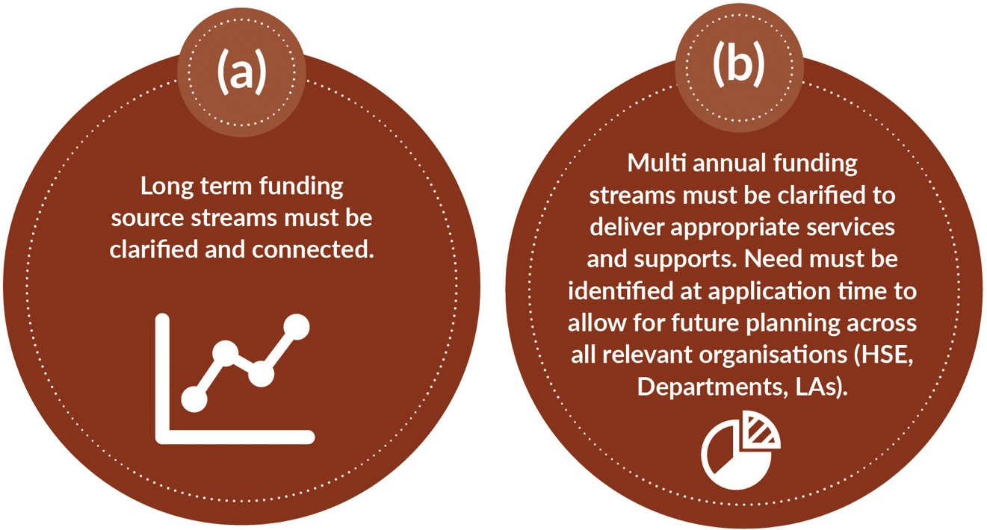

This Implementation Plan covers 27 Outcomes14, each of which has a set of Key Actions that will be required to deliver it, with 107 actions overall. Responsibility has been assigned to a lead organisation, with other partners identified. Timelines and Key Performance Indicators (KPI) are also set.

Theme 1 – Accessible Housing and Communities
Outcome 1.1 There is an increase in the provision of accessible housing for disabled people by the setting of local, need-related15 targets for all social housing providers using a universal design approach, as appropriate.

Action 1.1.1

Review Housing Delivery Action Plans (HDAPs) and ensure targets for delivery of housing for disabled people are being met. Where these targets are not being met ensure that the HDAPs are revised to meet that target within the lifetime of the HDAP.
- Lead: LAs
- Other Partners: DHLGH, AHBs
- Timelines: From Q4 2023
- KPI: Delivery targets for accessible housing are met

Action 1.1.2

Each Housing and Disability Steering Group (HDSG) will review their Local Strategic Plan (LSP) to take account of the outcomes and actions of the new Strategy and this Implementation Plan and to align with targets set in their Housing Delivery Action Plans and other actions from Housing for All.
- Lead: LAs
- Other Partners: HDSG member organisations
- Timelines: Q4 2023
- KPI: Local Strategic Plan reviewed and updated

Action 1.1.3

Housing and Disability Steering Groups will report quarterly on the implementation of their Local Strategic Plans regarding housing for disabled people to the Chief Executive and the Strategic Policy Committee.
Subsequently the report must be submitted to The Housing Agency who will be responsible for reporting at national level.
- Lead: LAs
- Other Partners: HDSG member organisations
- Timelines: Underway and ongoing
- KPI: Reports submitted to The Housing Agency

- Two of the outcomes are reflected together in the Implementation Plan – 3.1 and 3.2
- Need in the context of this plan is people on the Local Authority Housing Waiting and Transfer Lists

Action 1.1.4

Each local authority must ensure that they are aware of the housing need in their area by:
  - Recording the actual housing need of all new applications for social housing support where the basis of need is disability in a consistent way on the LA’s housing system.
    - Lead: DHLGH
    - Other Partners: LAs supported by HA, and The Local Government Management Agency (LGMA)
    - Timeline: Q3 2023
    - KPI: Local Strategic Plan reviewed and updated
  - Reviewing their Housing Waiting List to determine the needs of each individual that has a basis of need of disability and record the housing need of the household on the housing system.
    - Lead: LAs
    - Other Partners: LAs supported by HA, LGMA and DHLGH
    - Timeline: Q3 2023
    - KPI: Actual housing need recorded for all housing applicants
  - Using this data to strategically plan for the needs of disabled people in the area as set out in
1.1.1 above.
    - Lead: LAs
    - Other Partners: LAs supported by HA, LGMA and DHLGH
    - Timeline: Q3 2023
    - KPI: Actual housing need recorded for all housing applicants
  - Updating the iHouse and other systems to reflect the new requirements and develop auto- generation of reports for HDSGs.
    - Lead: LGMA
    - Other Partners: Supported by LAs
    - Timelines: Q2 2024
    - KPI: Computer systems can record the data

Action 1.1.5

DHLGH will consider the published analysis which is being conducted by the National Disability Authority (NDA) under Action 97 of the National Disability Inclusion Strategy and evaluate further actions to support the advancement of universal design principles in new housing.
- Lead: DHLGH
- Other Partners: NDA, HA
- Timeline: Within 6 months of the publication of the analysis which is being conducted by the National Disability Authority (NDA) under Action 97 of the National Disability Inclusion Strategy
- KPI: Consideration underway

Action 1.1.6

Promote the use of vacant ground floor commercial or retail units to deliver appropriate housing options for disabled people.

- Lead: HA
- Other Partners: LA, AHBs and DHLGH
- Timeline: From Q3 2023
- KPI: Number of units in use

Action 1.1.7

Promote awareness of the Department’s Design Manual for Quality Housing to ensure active delivery and promotion of standard layouts including for UD specific dwellings.

- Lead: DHLGH
- Other Partners: NDA, HA, LAs, AHBs and other stakeholders
- Timeline: Underway and ongoing
- KPI: Awareness of Design Manual

Action 1.1.8

Examine and document the current practice with regards to the provision of identified additional space for a household and develop a short briefing note for local authorities.

- Lead: HA
- Other Partners: LAs, AHBs, DHLGH, HSE and other stakeholders
- Timeline: Q1 2024
- KPI: Briefing note developed and circulated

Action 1.1.8

Examine and document the current practice with regards to the provision of identified additional space for a household and develop a short briefing note for local authorities.

- Lead: HA
- Other Partners: LAs, AHBs, DHLGH, HSE and other stakeholders
- Timeline: Q1 2024
- KPI: Briefing note developed and circulated

Action 1.1.9

Review and report on all delivery mechanisms for social housing to ensure the most effective mechanisms are used to deliver housing for disabled people. This includes Part V and other new initiatives as they arise.
- Lead: HA
- Other Partners: LAs and DHLGH
- Timeline: Q1 2024
- KPI: Report completed

Action 1.1.10

Engage with the Irish Council for Social Housing (ICSH) to promote partnerships between the major AHBs and disability service providers (including HSE) or arrangements whereby the housing elements of projects are managed on behalf of smaller disability service providers.
- Lead: DHLGH
- Other Partners: ICSH, AHBs and disability service providers
- Timeline: Underway and ongoing
- KPI: Engagement facilitated between major AHBs and disability service providers

Outcome 1.2 Disabled people are supported to avail of housing opportunities that arise through the increase in supports, both formal and informal.

Action 1.2.1

Examine the possibility of the provision of a service in sourcing accommodation similar to that of the Place Finders in Homeless Services and engage with the various stakeholders on the findings of the report in order to implement the recommendations, as appropriate.
- Lead: DHLGH
- Other Partners: DoH and HA
- Timeline: Q4 2023
- KPI: Examination of existing services and feasibility of service for disabled people

Action 1.2.2

Local authorities and the HSE work together to plan and deliver on housing targets for disabled people in the community (including de-congregation) in line with the forthcoming Disability Services Action Plan.
- Lead: LA, HSE
- Other Partners: All stakeholders including DoH and DHLGH
- Timeline: From Q3 2023
- KPI: Number of disabled people housed in the community annually

Action 1.2.3

Examine and document international practice around good practice options for disabled people living in the community including shared living arrangements.
- Lead: HA
- Other Partners: LA, HSE, other stakeholders
- Timeline: Q4 2023
- KPI: Report completed
Once completed engage with all stakeholders to identify good practice models to pilot in at least one area.
- Lead: LA, HSE
- Other Partners: HA, DHLGH, DoH, NDA
- Timeline: Commence by end 2024
- KPI: Pilot commenced
Document findings of the pilot and if appropriate promote different approaches to disabled people living with others with whom they would like to share accommodation.
- Lead: HA
- Other Partners: LAs, AHBs, DHLGH, DCEDIY, DoH
- Timeline: End of 2025
- KPI: Findings documented

Action 1.2.4

Monitor offers to ensure that accommodation offered is suitable for a household’s needs with specific disabilities through the quarterly reports to the Strategic Policy Committee and the Housing Agency.
- Lead: LAs

Other Partners: AHBs
- Timeline: From Q2 2023
- KPI: Number of refusals on unsuitability grounds is reduced

Outcome 1.3 Communities and housing developments are more accessible for disabled people.

Action 1.3.1

Use the review of the County/City Development Plans to promote accessibility in the wider community for disabled people including in transport, education, employment, and health services.
- Lead: LAs
- Other Partners: All stakeholders through the National Implementation Steering Group
- Timeline: As appropriate throughout the life of the strategy
- KPI: Review of CDPs conducted, and further periodic reviews conducted, to promote the use of accessibility and universal design
Use the County/City Development Plans to promote the use of Universal Design in private developments including the Part V obligations.
- Lead: LAs
- Other Partners: All stakeholders through the National Implementation Steering Group
- Timeline: As appropriate throughout the life of the strategy
- KPI: Review of CDPs conducted, and further periodic reviews conducted, to promote the use of accessibility and universal design

Carry out periodic reviews to document the promotion of accessibility in County/City Development Plans.
- Lead: HA

Other Partners: LAs
- Timeline: As appropriate throughout the life of the strategy
- KPI: Review of CDPs conducted, and further periodic reviews conducted, to promote the use of accessibility and universal design

Action 1.3.2

Examine good practice housing projects and housing designs to inform future accessible housing initiatives.
- Lead: HA
- Other Partners: LA, AHBs, HSE and other stakeholders
- Timeline: Ongoing from Q4 2023
- KPI: Briefing note developed and circulated

Action 1.3.3

The use of housing related Assistive Technology to be explored for its potential use in housing for disabled people, including assessing the viability of “smart homes” to provide appropriate assistive technology that can maximise independence.
- Lead: HA
- Other Partners: LA, AHBs, DHLGH, HSE, NDA and other stakeholders
- Timeline: Q1 2024
- KPI: Briefing note completed

Action 1.3.4

Engage with property developers and AHBs around making new developments more accessible. This engagement should not only be around the accessibility of the housing dwellings but must include the development in its entirety to ensure that the public realm is suitable for disabled people.
- Lead: LAs
- Other Partners: DHLGH, other stakeholders
- Timeline: From Q3 2023
- KPI: Developers and AHBs include more accessibility measures in their developments

Outcome 1.4 Local authorities strategically plan for the housing needs of disabled people in their administrative area.

Action 1.4.1

Local authorities must carry out an audit of their current social housing waiting list to establish the number of disabled people on the list, in line with Action 1.1.4.
- Lead: LAs
- Other Partners: HDSGs
- Timeline: Q1 2024
- KPI: Audit reports completed by all LAs

Action 1.4.2

Local authorities as part of their housing stock surveys should commence recording their current housing stock to establish the number of properties they have which are adapted for disability including the number of wheelchair liveable properties in their stock.
- Lead: LAs
- Other Partners: Supported by the LGMA, Housing Delivery Coordination Office (HDCO)
- Timeline: From Q3 2023
- KPI: Report available on adapted and accessible housing stock for each LA

Action 1.4.3

Each LA must retain records of the numbers and reasons why housing offers to households where the basis of need is disability, are being refused and report these quarterly to The Housing Agency in order to allow for better planning of the support needs of disabled people to allow them to avail of housing opportunities. This is linked to Action 1.2.4.
- Lead: LA, HA
- Other Partners: HSE
- Timeline: From Q2 2023
- KPI: Quarterly report collated by the HA

Action 1.4.4

All stakeholders must assist to inform the local strategic planning for the changing community support needs of disabled people in the community, and those who are living in the family home as their carers get older.
- Lead: HDSG members
- Other Partners: All stakeholders
- Timeline: From Q3 2023
- KPI: Local Strategic Plans reviewed annually

Outcome 1.5 Provision of housing and related supports that is in line with UNCRPD principles is supported through collaboration between the HSE and local authorities at both national and local level and appropriate funding.

Action 1.5.1

Engage with relevant stakeholders to ensure that there is knowledge and understanding of the funding models available for housing delivery.
- Lead: DHLGH
- Other Partners: HSE, AHBs, other HDSG members as appropriate
- Timeline: Underway and Ongoing
- KPI: Webinars or seminars held

Action 1.5.2

The HSE will provide information on newly supported places or expanded supports for existing places which were provided in the previous quarter, as part of the ‘quarterly reporting’ set out as part of Housing for All. This is to allow for holistic engagement by the HSE and LAs to ensure that housing opportunities are realised for disabled people.
- Lead: HSE
- Other Partners: LA and HDSG member organisations
- Timeline: Underway and ongoing
- KPI: Reports submitted

Action 1.5.3

Audit the potential of HSE and disability service providers’ campuses for delivery of suitable housing or for land swaps to facilitate provision of suitable housing or sites.
- Lead: HSE, DHLGH
- Other Partners: LAs and AHBs
- Timeline: Q1 2024
- KPI: Audit completed and actioned

Theme 2 – Interagency Collaboration and the Provision of Supports
Outcome 2.1 Disabled people have a clear pathway to accessing housing and support services.

Action 2.1.1

Each local authority is to nominate a representative from their Housing Departments to work closely with a person nominated by each CHO Mental Health and Disability Services to ensure that housing and support services are aligned as appropriate and to develop an early notification system so that housing will be available and support applications are processed accordingly.
- Lead: LAs and HSE
- Other Partners: HDSG members
- Timeline: Q3 2023
- KPI: Representatives appointed and collaboration protocols established
The parties will report to the HDSG meetings on the progress made as a result of this close working relationship.
- Lead: LAs and HSE
- Other Partners: HDSG members and HA
- Timeline: From Q4 2023
- KPI: Reports submitted to the HDSGs
A number of pilots will be established to test the system and amend as appropriate.
- Lead: LAs and HSE
- Other Partners: HDSG members and HA
- Timeline: Q4 2023
- KPI: Pilots established, evaluated and rolled out nationally
On the completion of the pilots the early notification system will be rolled out nationally.
- Lead: HA
- Other Partners: HDSG members, LAs and HSE
- Timeline: Q3 2024 for rollout
- KPI: Early notification system operational nationwide

Action 2.1.2

Extend the Mental Health Tenancy Sustainment Officer role nationally through the AHB sector to work with local authorities and Approved Housing Bodies to support people with mental health related difficulties to sustain their tenancies and prevent homelessness.
- Lead: HSE, DHLGH
- Other Partners: AHBs and LAs
- Timeline: Underway and ongoing for the lifetime of the strategy
- KPI: Mental Health Tenancy Sustainment Officers appointed and services are operational nationally

Action 2.1.3

The local authority Disability Friendly Technical Advisor will work with housing providers to assist with the technical aspects of housing development including procurement, assessment and appraisals.
- Lead: LAs
- Other Partners: AHBs and Service Providers
- Timeline: Ongoing from Q3 2023
- KPI: LA and AHBs procurement, assessment and appraisal processes are improved as a result of collaboration

Action 2.1.4

Examine existing models of housing and supports to inform and determine the optimum way that housing and support can be aligned to best meet the needs of disabled people.
- Lead: HA
- Other Partners: LAs and HSE with other stakeholders
- Timeline: Q2 2024
- KPI: Report developed and published

Action 2.1.5

The HSE will regularly review levels of need and work with service users to identify accommodation solutions at an early stage. Packages of care support for individuals and families will be reviewed as needed, having regard to budget.
- Lead: HSE
- Other Partners: LA and AHBs
- Timeline: Underway and ongoing
- KPI: Level of need is identified

Action 2.1.6

Review and update the protocols developed under the previous Strategy by the relevant stakeholders, as appropriate, to ensure that they are fit for purpose and to reiterate the commitment to the protocols. If a protocol is no longer required, all parties should be notified that it is being rescinded.
- Lead: DHLGH, and DoH
- Other Partners: LAs, HSE and HA
- Timeline: Q1 2024
- KPI: Protocols reviewed and updated

Action 2.1.7

Develop a protocol between the HSE and local authorities to allow for a review of applications to ensure that the needs of disabled people are being met from both housing and support perspectives. This should include scheduled review meetings between the LAs and HSE to allow for robust housing delivery planning to match identified housing including any required data gathering.
- Lead: DCEDIY, DHLGH, and DoH
- Other Partners: LAs and HSE
- Timeline: Q2 2024
- KPI: Protocol developed and implemented

Action 2.1.8

Examine the existing mechanism for households with disabled children that allow for a review of their social housing allocation as their needs change and timely facilitation of appropriate transfers to ensure that it is fit for purpose.
- Lead: DHLGH
- Other Partners: LAs and HSE
- Timeline: Q4 2023
- KPI: Mechanism reviewed and guidance issued

Outcome 2.2 A regulatory landscape/framework is in place that best supports the delivery of housing for disabled people.

Action 2.2.1

Examine the findings from the Cost of Disability in Ireland Research Report and apply, as appropriate, where related to the following:
- Social Housing Support
- Cost Rental
- Affordable Housing Schemes, and/or
- Housing Adaptation Grant for Persons with a Disability Scheme.
- Lead: DHLGH
- Other Partners: DoH, DCEDIY
- Timeline: a) End 2023
  - As a review of the scheme arises
  - As a review of the scheme arises
  - Complete
- KPI: Findings examined

Action 2.2.2

Examine the way the different regulatory frameworks interact with one another with a view to ensuring that they are not a barrier to the delivery of housing for disabled people.
- Lead: HA
- Other Partners: All Stakeholders
- Timeline: Q2 2024
- KPI: Report prepared

Action 2.2.3

Develop structures to support people to live full lives within their communities by:
- Firstly examining and documenting peer support models nationally and internationally.
  - Lead: HA, DHLGH, HSE
  - Other Partners: All Stakeholders
  - Timeline: Q1 2024
  - KPI: Report prepared
- The information documented should inform the establishment of peer support models at local level in a number of areas.
  - Lead: HA, DHLGH, HSE
  - Other Partners: All Stakeholders
  - Timeline: Q3 2024
  - KPI: Models established
- The learning from the initial peer support models will be documented and applied to the roll out of such initiatives nationally.
  - Lead: HA, DHLGH, HSE
  - Other Partners: All Stakeholders
  - Timeline: Q1 2025
  - KPI: Roll out of suitable initiatives

Action 2.2.4

Develop a template for Service Level Agreements between AHBs and service providers to ensure the correct support is in place and remains in place to ensure people can live independently in the community.
- Lead: HA
- Other Partners: AHBs and service providers
- Timeline: Q4 2023
- KPI: Template developed and circulated

Action 2.2.5

Engage with HIQA regarding people living in residential homes to ensure that they are awarded their rights as a tenant in the properties they live.
- Lead: AHBs and LAs
- Other Partners: HSE, DHLGH
- Timeline: From Q3 2023
- KPI: Working group established

Outcome 2.3 Local authorities and the HSE work and collaborate efficiently, improving access to housing for disabled people.

Action 2.3.1

As outlined in 2.1.1, each local authority will nominate a representative from their Housing Departments and the HSE will nominate a housing coordinator in each CHO area for both Mental Health Services and Disability Services to work closely together to act as a point of contact for each other in their organisations, in order to address issues and barriers to the increase in delivery of housing opportunities with related supports for disabled people.
- Lead: LAs, HSE
- Other Partners: DHLGH, DoH, HA, DCEDIY
- Timeline: Underway and ongoing. To be completed by Q3 2023
- KPI: Representatives appointed and collaboration protocols established

Action 2.3.2

Develop an interagency protocol that will ensure housing delivery is in line with effective support services to those who require it, similar to that of the Homeless Action Teams.
- Lead: HA
- Other Partners: LAs, HSE
- Timeline: Q4 2023
- KPI: Protocol implemented in all areas
A pilot should be established for a group as a subgroup to the HDSGs to test the protocol in 2 or 3 areas. These pilots will include regular reviews to identify barriers, risks and challenges to objectives as they arise, and to develop prompt and flexible responses through interagency collaboration.
- Lead: HA
- Other Partners: 2 to 3 LAs to be identified and relevant HSE CHO Management
- Timeline: Q1 2024
- KPI: Protocol prepared for use

Action 2.3.3

The Housing and Disability Steering Groups (HDSGs) have been identified in both Housing for All and the new Strategy as key to the implementation of the Strategy at local level. As a result, the following will be actioned:
- HDSGs will review their Terms of Reference and their frequency of meetings.
  - Lead: HDSGs
  - Other Partners: All HDSG Members
  - Timeline: Q4 2023
  - KPI: Each HDSG reviews their Terms of Reference and their membership and submits to the HA and National Implementation Steering Group

- HDSGs will review their membership and ensure there is representation from Disabled Persons Organisations (DPOs) on each group. Membership should be reviewed annually to ensure that there is fair representation.
  - Lead: HDSGs
  - Other Partners: All HDSG Members
  - Timeline: Q4 2023
  - KPI: There is an increase in DPO membership in all HDSGs
- HDSGs will report quarterly on their delivery, allocations, pipeline delivery and support packages.
  - Lead: HDSGs
  - Other Partners: All HDSG Members
  - Timeline: Underway and ongoing
  - KPI: Each HDSG coordinates with members and submits their quarterly returns to the HA and National Implementation Steering Group
- HDSGs will examine how members represent their sector and how the group supports members to report back to their sector.
  - Lead: HDSGs
  - Other Partners: All HDSG Members
  - Timeline: Q3 2023
  - KPI: Sector forums are established where representatives report to their sector
- Establish subgroups of the HDSGs to deal with specific issues or groups, as appropriate.
  - Lead: HDSGs
  - Other Partners: All HDSG Members
  - Timeline: Underway and ongoing
  - KPI: Subgroups established to deal with specific issues
- All stakeholders communicate on pipeline delivery to allow for effective planning including gains from the close working relationships.
  - Lead: HDSGs
  - Other Partners: All HDSG Members
  - Timeline: Underway and ongoing
  - KPI: Stakeholder communication on pipeline delivery in place
- Ensure that delivery is provided in a coordinated way without competition for existing supply.
  - Lead: HDSGs
  - Other Partners: All HDSG Members
  - Timeline: Underway and ongoing
  - KPI: Measures in place to reduce risk of competition

- A formal process will be put in place through The Housing Agency to allow HDSGs to escalate issues to be dealt with at a national level, as appropriate.
  - Lead: HA
  - Other Partners: All HDSG Members
  - Timeline: Q3 2023
  - KPI: Process in place
- HDSGs to encourage and facilitate smaller specialised AHBs to undertake new projects.
  - Lead: HDSGs
  - Other Partners: All HDSG Members
  - Timeline: Underway and Ongoing
  - KPI: HDSGs have reached out to smaller specialised AHBs in their area

Outcome 2.4 Local authorities, Approved Housing Bodies, the HSE and Service Providers work and collaborate efficiently, improving access to housing for disabled people, providing community-based residential care for disabled people, and working towards ending provision of residential care in institutional or congregated settings.

Action 2.4.1

In order to deliver on Action 8.1 of the Action Plan for Disability Services, support will be provided to build the capacity within the AHB sector to increase delivery of housing to support independent living in the community and implement de-congregation:
- Encouraging use of the DHLGH Design Templates where appropriate.
- Providing practical advice and support on projects from inception.
- Establish a network for the Disability Friendly Technical Advisors to allow for a coordinated approach to the support provided to AHBs, Service Providers and others.
- Lead: LAs and ICSH
- Other Partners: HA and DHLGH
- Timeline: Underway and ongoing
- KPI: a)Templates being used, b) Advice and support provided and c) Network established

Action 2.4.2

Examine the potential for the use of surplus HSE lands for mixed tenure developments.
- Lead: DHLGH, HSE
- Other Partners: DoH, AHBs, Land Development Agency
- Timeline: Q1 2024
- KPI: Examination complete

Outcome 2.5 The Assessment and Allocation Guidelines are embedded in the policies and procedures of the local authorities and the HSE.

Action 2.5.1

A review is to be carried out of the Assessment and Allocation Guidelines.
- Lead: HA
- Other Partners: All stakeholders
- Timeline: Q1 2024
- KPI: Review conducted and guidance document updated

Action 2.5.2

Each LA will embed the review of the Assessment and Allocation Guidelines into their policies and procedures
- Lead: LAs
- Other Partners: HA
- Timeline: Q2 2024
- KPI: LAs policies and procedures updated to reflect the findings of the review

Outcome 2.6 Coordination is improved and there is an increase of capital and revenue funding for housing and related supports.

Action 2.6.1

Tier 3 Approved Housing Bodies, are to be actively encouraged to link/partner with smaller AHBs to build capacity in the sector.
- Lead: DHLGH
- Other Partners: ICSH
- Timeline: From Q3 2023
- KPI: Guidance issued by ICSH to AHBs

Action 2.6.2

In order to ensure CAS funding is approved, the HSE will examine how funding for care and support packages can be pre-approved.
- Lead: HSE
- Other Partners: DHLGH
- Timeline: From Q3 2023
- KPI: Examination is completed

Theme 3 – Affordability of Housing
Outcome 3.1 & 2 Disabled people have access to affordable housing schemes including to purchase a home or rent at an affordable price.

Action 3.1.1

Review the implementation opportunities and challenges in the delivery of housing for disabled people via CAS.
- Lead: HA
- Other Partners: DHLGH, HSE, AHBS, LAs
- Timeli ne: Q4 2023
- KPI: Review complete

Action 3.1.2

Examine the Affordable Housing Schemes from a disability perspective in terms of:
- The ongoing policy development and the potential additional costs associated with property design for disabled people.
- The capacity for a mixture of dwelling types and sizes to be provided to reasonably match the requirements of eligible applicants including those with a disability.
- The current allocation processes and determine whether any changes may be required to ensure a level of provision is being made to disabled people.
- Lead: HA
- Other Partners: DHLGH, HSE, AHBS, LAs
- Timeline: From Q3 2023
- KPI: Examination complete and report prepared

Action 3.1.3

Prepare and circulate information on all affordable housing measures in accessible formats and ensure that access to schemes or application processes are in an accessible format.
- Lead: HA, DHLGH
- Other Partners: HSE, AHBs, LAs and NDA
- Timeline: From Q3 2023
- KPI: Information in accessible formats circulated

Action 3.1.4

Consider the inclusion of affordable housing schemes delivery targets for disabled people, where appropriate
- Lead: DHLGH
- Other Partners: HA, AHBs and LAs
- Timeline: From Q3 2023
- KPI: Delivery targets considered and introduced, where applicable

Action 3.1.5

Examine ways to increase the accessibility of the Cost Rental scheme for disabled people.
- Lead: HA, DHLGH
- Other Partners: DHLGH, AHBs and LAs
- Timeline: From Q3 2023
- KPI: Examination complete and report prepared

Action 3.1.6

Prepare and circulate information on Cost Rental in accessible formats and ensure that access to schemes or application processes are in an accessible format.
- Lead: HA, DHLGH
- Other Partners: AHBs and LAs
- Timeline: From Q3 2023
- KPI: Information in accessible formats circulated

Action 3.1.7

Consider the inclusion of cost rental scheme delivery targets for disabled people, where appropriate
- Lead: HA, DHLGH
- Other Partners: HSE, AHBs, LAs and NDA
- Timeline: From Q3 2023
- KPI: Delivery targets considered, and introduced, where applicable

Action 3.1.8

While noting that the Local Authority Home Loan (LAHL) is a repayable mortgage that allows applicants purchase a house at its market price, examine if other housing adaptation supports could be applied for at the same time as a disabled person is availing of the LAHL to buy a home. In this way a disabled person could buy a home using the LAHL in the normal way and be pre-approved with a housing adaptation grant to start adaptation works straight away.
- Lead: DHLGH
- Other Partners: N/A
- Timeline: Q4 2023
- KPI: Examination complete and any possible changes implemented

Outcome 3.3 Grant schemes funded by the various Government departments are fit for purpose and there is clarity on areas of responsibility including the use of technology.

Action 3.3.1

Review the range of housing grants available to assist with meeting specific housing needs, including the Housing Adaptation Grant for People with a Disability, and implement relevant changes in line with Action 7.4 of Housing for All.
- Lead: DHLGH
- Other Partners: All stakeholders
- Timeline: Q4 2023
- KPI: Revised Scheme in operation

Action 3.3.2

As part of the review of the Housing Adaptation Grant Scheme for People with Disabilities being conducted under Housing for All, explore the application process for the adaptation grants to further reduce processing times.
- Lead: DHLGH
- Other Partners: All stakeholders
- Timeline: Complete
- KPI: Review complete

Theme 4 – Communication and Access to Information

Outcome 4.1 A proactive and consistent approach is taken by agencies in the provision of information which is coordinated by The Housing Agency.

Action 4.1.1

Prepare and publish an Information and Communication Strategy. This will set out how communication will be conducted at national and local level during the lifetime of the Strategy.
This strategy will also be accompanied by an advisory note for local authorities and others on the use of communication tools such as JAM Cards, the co-correspondent form etc.
- Lead: HA
- Other Partners: All stakeholders
- Timeline: Q3 2023
- KPI: Strategy and advisory note prepared and published

Action 4.1.2

Local authorities, AHBs and the HSE will carry out an audit on what information on housing and related support need to be made more accessible for disabled people. This will be done through consultation and with input from the Housing and Disability Steering Groups and will include the following:
- Review the documentation in use and ensure that they use standardised templates.
- Ensure that the information is readily available and easily accessible on their websites.
  - Lead: LAs, AHBs, HSE
  - Other Partners: All stakeholders
  - Timeline: Q1 2024
  - KPI: Audit completed by all stakeholders and necessary changes implemented

Action 4.1.3

Local authorities (through their HDSG) organise events locally to raise awareness and promote housing opportunities to include:
- Informing about the importance for disabled people applying for Social Housing Support early to avoid emergency placements in group settings.
- Reaching out to isolated families in rural areas to apply for social housing support.
- Addressing negative attitudes towards disabled people living in the community, highlighting positive stories of people in local authority housing.
- Raising awareness of intersectional marginalisation that occurs for some disabled people as a result of their gender, sexuality, ethnicity etc. and how this negatively impacts their ability to secure appropriate accommodation.
- Residing in community living for those with mental health difficulties.
- Lead: LAs
- Other Partners: All stakeholders
- Timeline: Ongoing from Q3 2023
- KPI: Awareness event programmes prepared and commenced

Action 4.1.4

Promote the use of the Library Service as a point for accessing information.
- Lead: LAs
- Other Partners: All stakeholders
- Timeline: Q3 2023
- KPI: Information available from libraries

Outcome 4.2 There is an increase in the communication between State Agencies and disabled people regarding their housing opportunities both from a housing and support perspective.

Action 4.2.1

Disabled people to be consulted on new housing initiatives to ensure that when operationalised that the schemes are accessible and appropriate to disabled people.
- Lead: DHLGH
- Other Partners: All stakeholders
- Timeline: Ongoing from Q3 2023
- KPI: Consultations held and recommendations provided for new initiatives

Action 4.2.2

Increase awareness of applying for housing and support services by outlining clear steps on how disabled people can apply. This will be supported by the Housing and Disability Steering Groups (HDSGs).
- Lead: LAs and HSE
- Other Partners: All stakeholders
- Timeline: Ongoing from Q3 2023
- KPI: A process is outlined

Action 4.2.3

The Public Participation Networks (PPNs) will disseminate information on disability, housing and community issues to their communities, and will be involved in delivering information sessions
- Lead: PPNs
- Other Partners: All stakeholders
- Timeline: From Q3 2023
- KPI: Information sessions delivered and information disseminated to public

Action 4.2.4

Local authorities provide annual updates in an accessible format to applicants regarding their status on the list.
- Lead: LAs
- Other Partners: Supported by LGMA
- Timeline: Q2 2024
- KPI: LAs have system in place to provide annual updates

Action 4.2.5

Local authorities to assess the feasibility of an online Social Housing Support Application that allows individuals to upload change of circumstances at any time and to allow for the Summary of Social Housing Assessment to be carried out online.
- Lead: LAs
- Other Partners: Supported by LGMA
- Timeline: Q3 2024
- KPI: Feasibility examination complete

Outcome 4.3 People are supported to have the time and opportunity they need to engage with services and local authorities.

Action 4.3.1

Continue to ensure that disabled people including Disabled Persons Organisations (DPOs) are included in all consultation.
- Lead: DHLGH
- Other Partners: DoH, DCEDIY, LAs and AHBs
- Timeline: Underway and Ongoing
- KPI: Consultations to be held with DPOs

Action 4.3.2

Put in place a central point of contact for disabled people within local authorities.
- Lead: LAs
- Other Partners: DHLGH
- Timeline: Q4 2023
- KPI: Local authority support for disabled people in place in all local authorities

Action 4.3.4

Review Choice Based Lettings (CBLs) as a method of allocating housing for disabled people to ensure where it is used that it is accessible and address any issues highlighted.
- Lead: LAs
- Other Partners: Support of HA and other stakeholders
- Timeline: Q1 2024
- KPI: Reviews completed and necessary changes implemented

Action 4.3.3

Put in place a central point of contact for disabled people for housing related supports in each CHO area.
- Lead: HSE
- Other Partners: DoH, DCEDIY
- Timeline: Q4 2023
- KPI: Housing Supports Officer appointed in all CHO areas

Outcome 4.4 Information is provided in accessible formats in the one location.

Action 4.4.1

Housingdesignforall.ie will be used as a platform to develop a new dynamic and accessible repository of information on housing and related matters to include:
- Information on housing and related matters will be provided in various formats that are accessible and easily located.
- Where possible, information from all stakeholders will be provided as part of the site with links provided to external useful information that cannot be held locally or is subject to ongoing change.
- Mapping tools for application processes will be included to allow disabled people to visualise the application processes and timescales involved.
- Lead: HA
- Other Partners: All stakeholders
- Timeline: Q2 2024
- KPI: Website launched

Outcome 4.5 Better sharing of data to produce more collated data.

Action 4.5.2

Engage with relevant stakeholders to provide clarity on what type of information can be shared from the social housing application form between organisations such as LAs, AHBs, HSE. This will involve identifying the types of situations where relevant stakeholders are unclear about what data can be shared in the best interests of applicants, while also ensuring compliance with GDPR.
- Lead: DHLGH
- Other Partners: LAs and HA
- Timeline: Q1 2024
- KPI: Review completed and necessary changes implemented

Action 4.5.1

Develop data sharing protocols between organisations to optimise end results for service users. This is to be modelled on what is in place in the homeless sector.
- Lead: HA
- Other Partners: HSE, LAs, AHBs
- Timeline: Q1 2024
- KPI: Protocols prepared for use

Action 4.5.3

Build on the data prepared and published as part of the Strategy including the annual update of the Analysis of Households with a Disability Basis of Need for Social Housing 2016 – 2020. The report will be expanded to include identified need from 2024 onwards.
- Lead: HA
- Other Partners: LAs, DHLGH and LGMA
- Timeline: Ongoing from Q3 2023
- KPI: Report updated annually following the completion of the Summary of Social Housing Assessment

Action 4.5.4

In line with Action 2.1.5 above, local authorities and the HSE will work together to determine how information can be shared and data collected to allow for more strategic planning for the delivery of housing with related supports for disabled people.
- Lead: HA
- Other Partners: LAs, HSE, DoH and LGMA
- Timeline: Ongoing from Q3 2023
- KPI: Data sharing/collection process in place between LAs and the HSE

Action 4.5.5

Conduct a mapping exercise of county wide services under housing, health, and community for each county.
- Lead: HDSGs
- Other Partners: All Stakeholders
- Timeline: Q2 2024
- KPI: Mapping exercise completed and report produced

Theme 5 – Knowledge, Capacity, and Expertise

Outcome 5.1 Local authorities, the HSE and Approved Housing Bodies have the knowledge base, expertise and capacity to provide services and relevant information to disabled people.

Action 5.1.1

Develop a training programme for Housing Practitioners to include:
- The provision of accessible information and communications with disabled people including Irish Sign Language.
- Disability awareness training (JAM cards etc).
- Communication skills to enable a drop-in service that supports people to get information.
- Public Sector Duty and how it relates to housing.
  - Lead: HA
  - Other Partners: LAs, AHBs and other stakeholders
  - Timeline: From Q1 2024
  - KPI: Training programmes developed and delivered

Action 5.1.2

Explore opportunities for training/information sessions and cross-organisational training on relevant issues such as the social model of disability and centring on the voice of disabled people.
- Lead: HA
- Other Partners: All stakeholders
- Timeline: Ongoing from Q1 2024
- KPI: Scoping exercise on training and information conducted, and training delivered

Action 5.1.3

Continue to provide training to LAs and AHBs on mental health, to address stigma and misconceptions.
- Lead: HA
- Other Partners: LAs and AHBs
- Timeline: Underway and ongoing
- KPI: Training programme prepared and training delivered

Action 5.1.4

Training to be provided to Housing and Disability Steering Group members on role/purpose of groups.
- Lead: HA
- Other Partners: All stakeholders
- Timeline: Ongoing from Q4 2023
- KPI: Training programme prepared and delivered

Action 5.1.5

HDSGs organise “shared learning” days in their local authority where representatives from LAs and disability services share learning with members.
- Lead: HDSGs
- Other Partners: All stakeholders
- Timeline: Ongoing from Q3 2023
- KPI: Timetable prepared and “shared learning” days held

Action 5.1.6

Provide training to HSE staff on housing and good practice housing models.
- Lead: HA
- Other Partners: HSE and all other stakeholders
- Timeline: Ongoing from Q4 2023
- KPI: Training programme prepared and delivered

Outcome 5.2 Knowledge and expertise regarding disability issues are integrated into all relevant organisations.

Action 5.2.1

Following on from Action 4.1.1 and the publication of the Information and Communication Strategy, provide an effective communication model to be shared among all stakeholders, to share knowledge and enable effective planning.
- Lead: HA
- Other Partners: LAs, HDSGs
- Timeline: Q3 2023
- KPI: Communication model prepared, disseminated and implemented by stakeholders

Outcome 5.3 There is an understanding of each other’s roles among the various stakeholders which results in an improved service to disabled people.

Action 5.3.1

Design and deliver training sessions for stakeholders around all roles and responsibilities, creating a shared understanding of the role and responsibilities of each department and stakeholder.
- Lead: HA
- Other Partners: HSE, LAs and AHBs
- Timeline: Q1 2024
- KPI: Training programme prepared and delivered

Action 5.3.2

Develop protocols/guidelines outlining the responsibilities of all stakeholders and align objectives between housing and health.
- Lead: HA
- Other Partners: HSE, LAs and AHBs
- Timeline: Ongoing from Q1 2024
- KPI: Protocols prepared and implemented

Outcome 5.4 Local authority and Approved Housing Body staff implement the changes required to meet their obligations under the Assisted Decision-Making Act 2015.

Action 5.4.1

Prepare and deliver a training programme to local authority housing staff and staff from Approved Housing Bodies on the process and procedural changes required to implement the Assisted Decision-Making Act 2015.
- Lead: HA
- Other Partners: LAs and AHBs
- Timeline: Underway and ongoing
- KPI: Training programme prepared and delivered

Action 5.4.2

Develop guidelines on Assisted Decision Making for local authorities and AHBs.
- Lead: HA
- Other Partners: LAs and AHBs
- Timeline: Within 3 months of commencement of the Act
- KPI: Guidelines developed and in place

Action 5.4.3

Incorporate the principles of Assisted Decision-Making (Capacity) Act 2015 into all awareness campaigns.
- Lead: LAs
- Other Partners: All stakeholders
- Timeline: Within 3 months of commencement of the Act
- KPI: Awareness campaigns highlight the importance of ADM

Theme 6 – Strategy Alignment
Outcome 6.1 The Strategy is underpinned by Housing for All and the new Local Delivery Action Plans established under its framework.

Action 6.1.1

Highlight to all partners ways the new Strategy and accompanying Implementation Plan aligns with Housing for All.
This involves highlighting the following actions from Housing For All:
- Local Authority Housing Delivery Action Plans will set out how dedicated social housing provision appropriate to the needs of disabled people will be delivered matching the scale and extent of housing need identified for disabled people.
- Local authorities will consider the housing needs of disabled people through the Housing Need and Demand Assessment Framework and feed that into their housing strategies as part of their Development Plan process.
- Nominate Disability Friendly Housing Technical Advisors in each local authority.
- Lead: DHLGH
- Other Partners: Supported by HA
- Timeline: Underway and ongoing
- KPI: Relevant Housing for All actions highlighted in Policy Mapping Document and shared with partners

Action 6.1.2
Carry out a formal review of the Implementation Plan. This review shall include:
- A relevance check on current ongoing actions.
- Lead: HA
- Other Partners: All stakeholders
- Timeline: Commencing Q2 2024
- KPI: Review completed and report completed
- Actions for the remaining term of the Strategy.
- Lead: HA
- Other Partners: All stakeholders
- Timeline: Q3 2024
- KPI: Review completed and report completed
A draft report will be provided no later than Q3 of 2024 to the three Departments for review and agreement prior to publication.
- Lead: HA
- Other Partners: All stakeholders
- Timeline: Q4 2024
- KPI: Publication of report

Outcome 6.2 The Government strategies such as Sharing the Vision, A Time to Move on from Congregated Settings complement and feed into the new National Housing Strategy for Disabled People and associated Implementation Plan.

Action 6.2.1

Allow people transitioning from congregated settings to be placed on the transfer list outside of the current transfer rules of the LA requirements if such a move is requested due to a change in the individual’s will and preference, where the original will and preference was articulated without full knowledge or understanding.
- Lead: LAs
- Other Partners: HSE and Service Providers
- Timeline: Q3 2023
- KPI: Guidance provided to LAs and the Assessment and Allocation Guidance updated to reflect same

Action 6.2.2

Local authorities will work with HSE and disability and mental health service providers around housing to accommodate people transferring from congregated settings.
- Lead: LA, HSE
- Other Partners: DHLGH, disability and mental health service providers
- Timeline: Underway and ongoing
- KPI: People move from congregated settings

Action 6.2.3

Include disabled people in future discussions and plans on homelessness by ensuring the specific inclusion of disabled people in Regional Homelessness Action Plans.
- Lead: DHLGH
- Other Partners: All stakeholders
- Timeline: Q3 2023
- KPI: Disabled people are involved in the consultation for the preparation of Regional Homelessness Action Plans

Action 6.2.4

Local authorities will be positively open to offering transfers to disabled people where the current accommodation including location is no longer appropriate for the disabled person.
- Lead: LAs
- Other Partners: HSE and service providers
- Timeline: Underway and ongoing
- KPI: Guidance provided to LAs and the Assessment and Allocation Guidance updated to reflect same

Action 6.2.5

Develop a clear and detailed plan for de-congregation for people with mental health difficulties such as the one prepared by the HSE for people with an intellectual disability.
- Lead: HSE
- Other Partners: DoH and DHLGH
- Timeline: Q2 2024
- KPI: Plan developed

Action 6.2.6

Examine what safeguards and minimum standards can be introduced to aid and protect disabled people accessing housing and sustaining tenancies in the private rental sector.
- Lead: DHLGH
- Other Partners: DoH and DCEDIY
- Timeline: Q3 2024
- KPI: Report prepared

Action 6.2.7

Ensure that Recommendations 67 and 68 from Sharing the Vision are delivered on.
- Lead: DoH
- Other Partners: DHLGH, LAs, HA
- Timeline: Q4 2025
- KPI: KPIs set in Sharing the Vision
Below are the recommendations from Sharing the Vision.
Recommendation 67: Local authorities should liaise with statutory mental health services to include the housing needs of people with complex mental health difficulties as part of their local housing plans.
  - Lead: DoH
  - Other Partners: DHLGH, LAs
  - Timeline: Q4 2025
  - KPI: Housing needs of people with complex mental health difficulties are met
Recommendation 68: The Department of Health and the Department of Housing, Planning and Local Government, in consultation with relevant stakeholders, should develop
a joint protocol to guide the effective transition of individuals from HSE-supported accommodation to community living.
  - Lead: DoH
  - Other Partners: DHLGH, LAs
  - Timeline: Q3 2023
  - KPI: Implementation of agreed joint protocol

Action 6.2.8

Each local authority and the HSE conduct an internal review of their policies and procedures to ensure that they are aligned to these Strategies.
- Lead: LA, HSE
- Other Partners: All stakeholders
- Timeline: Q1 2024
- KPI: Review conducted by all stakeholders and necessary changes implemented

Outcome 6.3 The Implementation Plan for this Strategy will take cognisance of the Disability Capacity Review to 2032 and Wasted Lives.

Action 6.3.1

Commence implementation of planned actions to address capacity deficits identified in the Disability Capacity Review to 2032, when Government adopts an implementation plan in that regard.
- Lead: DCEDIY and HSE
- Other Partners: All stakeholders, DoH
- Timeline: As per Implementation Plan for Disability Capacity Review
- KPI: As per Implementation Plan for Disability Capacity Review

Action 6.3.2

Implement relevant actions set out in an implementation plan for the Disability Capacity Review.
- Lead: DHLGH
- Other Partners: As per Implementation Plan for Disability Capacity Review
- Timeline: As per Implementation Plan for Disability Capacity Review
- KPI: As per Implementation Plan for Disability Capacity Review

Action 6.3.3

In line with the UNCRPD principles, adopt a person-centred approach to housing and related support services for disabled people.
- Lead: HSE
- Other Partners: LAs
- Timeline: Underway and ongoing
- KPI: Person-centred approach is the norm

Action 6.3.4

Co-ordination at local level between housing authorities and HSE when individuals are being supported to transfer from unsuitable nursing home placements to the community.
- Lead: LAs and HSE
- Other Partners: N/A
- Timeline: Underway and ongoing
- KPI: Practical co-operation is in place

Outcome 6.4 There is an alignment of strategies promoting the rights of disabled people so housing provision is not considered in a silo.

Action 6.4.1

Continue to monitor the Strategy and its Implementation Plan to ensure it is in line with the UNCRPD and any cross Departmental UNCRPD plans and strategies, to ensure that housing provision and related support services are considered and delivered in tandem.
- Lead: HA
- Other Partners: All stakeholders
- Timeline: Underway and ongoing
- KPI: Monitoring process established for Implementation of Strategy, and regular scoping exercises of other strategies conducted

Action 6.4.2

Coordinate the alignment of policy and departmental priorities at an inter-Departmental level, national operational level and at local level.
- Lead: HA
- Other Partners: DHLGH, DCEDIY and DoH
- Timeline: Underway and ongoing
- KPI: Departmental and policy priorities aligned

Action 6.4.3

Examine all new legislation affecting the housing and support requirements for any impact on disabled people.
- Lead: DHLGH, DCEDIY and DoH
- Other Partners: LAs, HSE and all stakeholders
- Timeline: Underway and ongoing
- KPI: Legislation affecting the housing and support requirements for disabled people is examined

Action 6.4.4

Engage with relevant local and national policies, services and delivery that may impact on the success of this Housing Strategy – for example accessible infrastructure, transport and supportive communities, with a view to addressing and resolving any inconsistencies or difficulties.
- Lead: DHLGH, DCEDIY and DoH
- Other Partners: All stakeholders
- Timeline: Underway and ongoing
- KPI: Engagement has taken place

Action 6.4.5

The Department of Housing, Local Government and Heritage will contribute to the UNCRPD Accessibility Action Plan.
- Lead: DHLGH
- Other Partners: All stakeholders
- Timeline: Underway and ongoing
- KPI: Department contribution prepared and submitted

